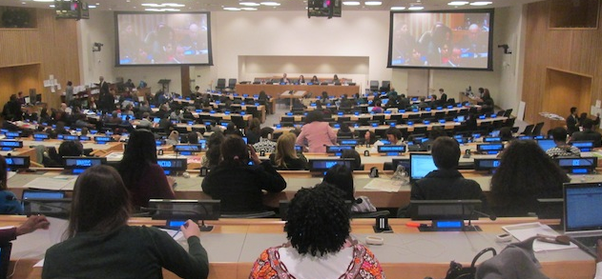

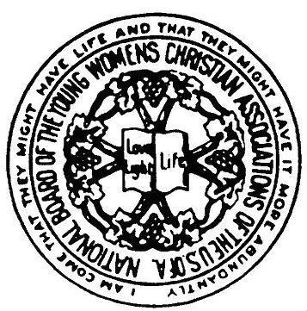

A Primer for WSC Members and Friends on CSW 58,
the urgently needed Annual UN Meeting of the Commission on the Status of Women just concluded in New York City.

While the media generally ignores this important annual United Nations event, many women in New York have just attended a remarkable two-week conference there called the Commission on the Status of Women (CSW.) Over 3000 women and some 200 men leaders from the UN’s 193 member countries attended this year as they have for the past thirty years. The Commission was created along with the UN itself in 1946 as a part of ECOSOC, one of the main bodies of the United Nations, which is in charge of economic and social affairs. The stated purpose of CSW is to report on women’s rights and make recommendations every year on urgent problems of women requiring action.

So every March, large or small groups of international women, distinguished leaders and average volunteer citizens of other countries, with many in native dress, gather in our city to act as official and
volunteer delegates to CSW and to present their problems and issues. They attend the very crowded 100 official sessions and 350 side meetings that take place for the first ten days, while about 1000 stay for the final days of official summary and conclusion. During CSW, there are 45 Commissioners who are authorized to hear the Women’s reports and monitor such issues as gender equality at these sessions. These officials are elected from member countries representing the world’s five regions for four-year rotation terms, and they themselves meet in Geneva in July to decide on remedial actions or answers.

All of these CSW meetings are obviously important if countries or their women want the United Nations to help correct critical problems such as the massive rape of women in areas under wartime conditions like South Sudan today, or the increased trafficking of women in the Far East, or the ongoing epidemic of HIV AIDS in Africa, particularly for women and adolescent girls. But other more general conditions of severe inequality and deprivation for women are also just as important for women in countries supposedly at peace. Looking at the extensive list of topics presented this year, there were some 60 sessions every day covering the following general areas of women’s issues in order of number presented, prominence and urgency:

1. Violence against women of all kinds, from wartime to domestic, sexual, and
killing of girl-infants or children
2. Trafficking, plus shelter problems of refugee, migrant, & displaced women
3. Equal education at all levels for girls, women; STEM; religious educ. issues
4. Health and Sexual/reproductive health; equality in HIV/Aids care and services
5. Economic and employment equality, rights; training; leadership for women
6. Special needs of adolescents and girls; sexual, violence, participation, schools
7. Men as partners; movements, involvement
8. Sustainable development; climate, food needs and effect on women

9. Broad issues of peace, poverty, and war and their effects on women
10. Issues of specific groups: LBGT, rural, prostitutes, disabled women and girls

Finally, there were numerous meetings at all levels on the subject of actions that women hope the UN will take in 2015 when several key Millennium Development Goals (MDGs) expire that were intended to help women and were voted on by the UN in 2000. Also, there was extensive discussion of the goals voted on at the 1995 Women’s Conference in Beijing that are twenty years old – with most of them still unrealized! These broad world goals for women cover many of the same areas listed above, and at all the sessions, prominent women and girls shared graphic stories and pleas for needed action and remedies that deserve much more attention and action from the UN and us all than they have received so far. The UN entity called UN Women, has the ongoing responsibility for furthering the results of these and other such conferences, and will try to do so. UN Women was recently reorganized and strengthened in 2012 and has a former World YWCA staff leader and Deputy Prime Minister of South Africa named Phumzile Mlambo Ngcuka, as its current Executive Director.

So what are the hoped-for results of this CSW conference that has just ended this week? First of all, there will be a document of “Agreed Conclusions” that may be as long as 60 or 70 pages and that will be submitted to the Commissioners for their action and recommendations to ECOSOC. That document is currently being worked on by government representatives with attention to all major complaint and action points agreed to by them; copies are also being sent to all participants and UN leaders and are available on various websites. Then there seems to be a real groundswell for recommending major new goals for women’s rights and human rights for the years after 2015. We should all be on the lookout for strong United Nations action on “Post-15 MDG Goals” with the Elimination of Violence Against Women” hopefully being a major one to be proposed and adopted at the highest level at
UN sessions in 2015.

If these moves don’t end in major steps to improve the rights of women, then there is one more avenue that many delegates see as a possible future step. It is to have the legal convention known as the Convention on the Elimination of all forms of Violence and Discrimination against Women, or CEDAW, be adopted by major cities in the United States in a move to force the U.S.A government to sign the agreement, which has already been signed by 190 countries. The U.S.A is one of only three countries (the other two being Iran and Sudan) which has not signed this agreement – CEDAW -partly because the U.S. government has always been leery of ceding any final authority to any international body – even if our country is in the vanguard of equal rights for women. CEDAW allows women to bring remedial action complaints to the UN and even possibly to get international court action. San Francisco and its mayor have gone on record as supporting a vote to adopt CEDAW, and there are moves to bring a campaign for cities to New York City and other major sites.

So the fight for women’s rights and protection is continuing even as the 58th session of the CSW ends this March, and we will try to keep our readers posted on any hopeful action or outcomes. The World YWCA, as one of the oldest and largest Non-Governmental Organizations (NGOs) and as a prominent member, was invited to attend and have speakers at many of the sessions, and there were an additional 90 other NGO organizations that also sponsored or spoke at other lectures as well. Please look at the stories of special meetings and presentations on our website: ywcaworldservicecouncil.org You can also link there to facebook (f) or if you don’t have a facebook account, you can see those articles on the WSC website by clicking on them in the small facebook box on the WSC home page.
Meanwhile, we hope that all of us will keep tuned for future news of the UN and its ongoing critical work on behalf of the women in our 120 World YWCA member countries and around the world!

Connie Tate, Chair of WSC, March 2014

